A Day out to Explore the

Black Country Living Museum
This fascinating open-air museum is filled with costumed characters who will explain what it was like to live and work in one of the world’s most heavily industrialised landscapes; explore original period shops and houses; watch live demonstrations, or descend underground into the coal mine. Take a ride on the vintage trams and buses; visit the school, the fairground and the Fish and Chip shop. There is even a traditional “spit and sawdust” pub!

The Black Country Living Museum is the “official home of Peaky Blinders” the popular BBC TV show. Walk in the footsteps of the Shelbys, and visit the Peaky shop. Take a peek behind the scenes in the Workers Institute or the Back Alleys.

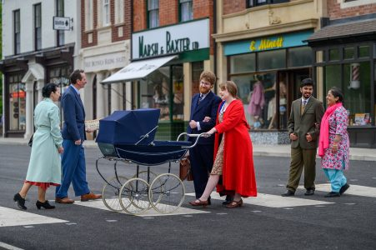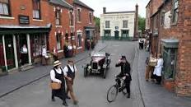

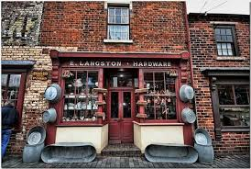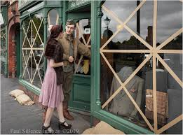

Add your name to the attached list (or call me 01270 812114, royplume@gmail.com) to join this coach trip to Dudley, about 1.5 hour each way

Leave Audlem Car park at 10am on Wednesday 4th October return by 5pm.

Price is £40 per head and includes cost of entry to the museum and the coach.

