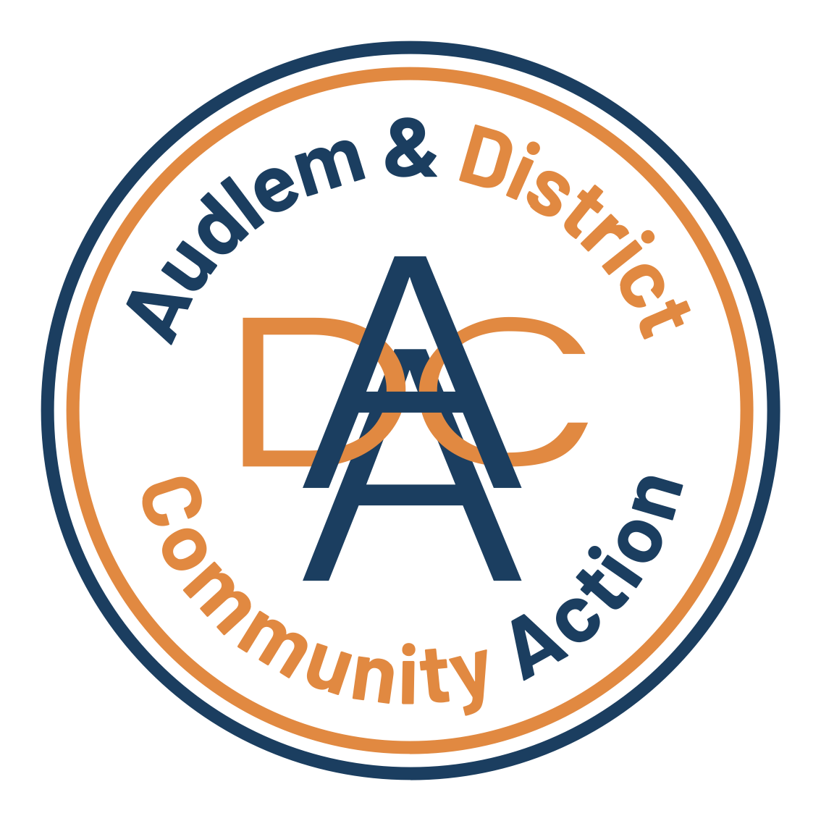
for the community, by the community….
Audlem & District Community Action (ADCA)
Assistant Manager – Operations
Audlem & District Community Action is seeking an experienced and motivated Assistant Manager Operations to support the General Manager, lead the development of new Carers’ Groups, and play a central role in delivering our ambitious 5-Year Business Plan.
This is an exciting opportunity to join ADCA at a pivotal stage in our development. As part of the charity’s executive team, the successful candidate will help shape the future direction of the organisation, strengthen strategic partnerships across the VCFSE and statutory sectors, and ensure ADCA continues to respond effectively to the evolving needs of older and vulnerable people in our rural community.
The role offers genuine scope for growth as the organisation develops

About the Role
Key responsibilities will include:
- Establishing and developing new Carers’ Groups to support unpaid carers across our area
- Translating ADCA’s strategic vision into practical, high-quality community services
- Supporting the General Manager with operational leadership and service delivery
- Contributing to the implementation of ADCA’s 5-Year Plan and future sustainability
- Building and maintaining strong partnerships within the voluntary, community, faith and social enterprise (VCFSE) sector and with statutory agencies
- Representing ADCA professionally at partnership meetings and community forums
- Supporting volunteer development and ensuring safe, effective service provision

About You
We are looking for someone who:
- Has experience within the charity, community, health, or social care sector
- Is confident engaging with a wide range of people including carers, volunteers, trustees, statutory partners, and funders
- Can represent the organisation credibly and professionally in external settings
- Can translate strategy into delivery and turn vision into practical outcomes
- Demonstrates strong organisational skills and the ability to manage competing priorities
- Has a clear understanding of safeguarding responsibilities, confidentiality, and professional boundaries
- Is committed to strengthening community resilience and improving support for unpaid carers
A genuine commitment to supporting vulnerable people in rural communities is essential.
Hours & Salary – £236 per week (16 hours at £14.75 per hour). £12,272 per year (based on 16 hours/week)
How to Apply - Please send a CV and a brief covering statement outlining your interest in the role and how your experience aligns with ADCA’s future direction or for an informal discussion. Please contact: admin@adca.org.uk Closing date: Monday 13th April 2026
ADCA welcomes applications from all sections of the community.
Audlem and District Community Action - bringing the community together
Enquires: refferals@adca.org.uk M: 07894 785907 E: admi@adca.org.uk

Company No: 07547410 Charity No: 1144074

