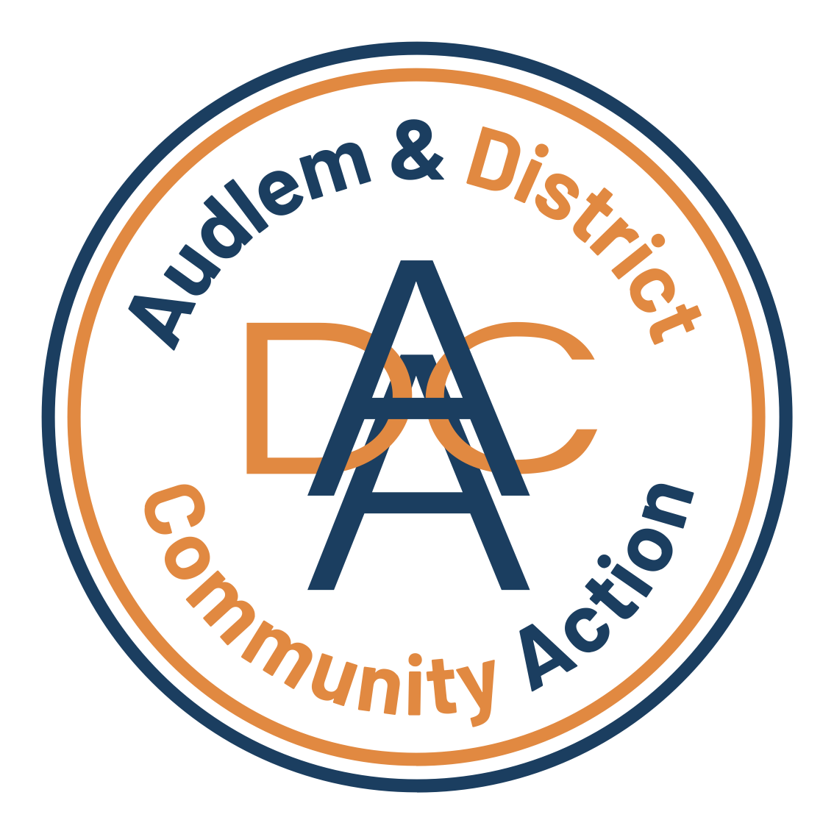
for the community, by the community….
Audlem & District Community Action (ADCA)
Charity Administrator
Audlem & District Community Action (ADCA) is looking for a highly organised and motivated Charity Administrator to join our team. We support older and vulnerable people across rural Cheshire, running lunch clubs, social activities, community transport, dementia support, and more.
As our Charity Administrator, you’ll be the heartbeat of the charity—keeping everything running smoothly behind the scenes. From managing office systems and supporting our trustees, to helping with fundraising and volunteer coordination, your work will directly impact the lives of those we support.
What you’ll do:
- Keep our office and records running like clockwork.
- Support trustees and staff with meetings, reports, and governance.
- Help with fundraising, grant applications, and community communications.
- Coordinate volunteers and liaise with service users.
What we’re looking for:
- Brilliant organisational and admin skills.
- Confident communicator—written and verbal.
- IT savvy (MS Office, databases, online tools).
- A team player with initiative, reliability, and a passion for helping others.
Why join ADCA?
- Be part of a friendly, community-focused charity.
- Flexible working and a supportive environment.
- Make a tangible difference to older and vulnerable people in your area.
Ready to make an impact?
Send your CV and a covering letter to [email/contact]. Closing date: [Insert date]
A genuine commitment to supporting vulnerable people in rural communities is essential.
Hours & Salary – £152.52 per week (12 hours at £12.71 per hour). £7,931.04 per year (based on 12 hours/week)
How to Apply - Please send a CV and a brief covering statement outlining your interest in the role and how your experience aligns with ADCA’s future direction or for an informal discussion. Please contact: admin@adca.org.uk Closing date: Monday the 13th April 2026
ADCA welcomes applications from all sections of the community.
Audlem and District Community Action - bringing the community together
Enquires: refferals@adca.org.uk M: 07894 785907 E: admi@adca.org.uk

Company No: 07547410 Charity No: 1144074

